Technical Design

Team: | Phantom | ITN: | 3 |  |  | Solution Design
 |  | Pipeline(s):
  MH5

Solution Design 1
Pipeline(s): 1
1 Introduction 1
1.1 Link to Requirements Document 1
1.2 Requirements 1
User Story 1
2 Design Discussion 2
2.1 Use Case 2
2.2 Class Diagrams 2
3 Implementation 2
3.1 Files 3
4 Testing Considerations 5
5 Screenshots 5

Introduction
This is a web-based application used to manage the contacts for a firm. The contacts are stored in a secure location on an internal server and the user is able to log in to the system using their access details.
The user can perform CRUD operations based on the privileges provided to them by the administrator.

Link to Requirements Document
https://jira2.cerner.com/browse/DEVACDMY-5165

Requirements

User Story
User Story ID | MH5
Story | View person details
Description | The user is able to view the details about the person.

Design Discussion

2.1 Use Case
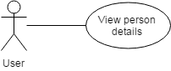
Figure 1 Use case for viewing person details

2.2 Class Diagrams
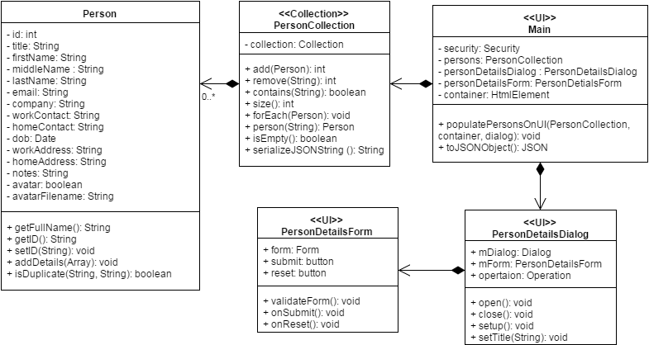
Figure 2 Class Diagram for listing contact

Implementation

The main objective is to allow the user to view the person details of the selected person. The implementation details are as follows:

- The list of persons is stored in a collection object called PersonCollection.
- When the user selects a person, the person details are fetched from the collection corresponding to the id of the selected person.
- A dialog containing the form to show the details of the person is opened.
- The form is populated with the person details fetched and shown to the user.
- The fields that are empty are left blank.
- The date is converted to the system date format.

Files
3.1.1 JAVASCRIPT

File | scripts/js/Main.js
Description | This class creates the objects for the application and sets up the click and submit events. It directly deals with UI elements to implement business logic.
Pseudo Code | // box onClick event  $(('#box' + id + '-click')).unbind().click(function(){  this.boxId = this.id.replace("box","").replace("-click","");  dialog.open();  var form = dialog.getForm();  form.reset();  form.populate(personCollection.person(this.boxId));  });
Passive (Yes/No) | Yes

File | scripts/js/Person.js
Description | This class is a representation of an actual person with person details defining the state and functions defining the behavior of the person.

File | scripts/js/PersonCollection.js
Description | This class is an implementation of the Collection class adapted to contain a collection of Person objects. It has methods like add(), remove(), contains(), size() etc.

File | scripts/js/PersonDetailsDialog.js
Description | This class is the representation of the html dialog on the UI.
Pseudo Code | function open (){  this.mDialog.dialog('open');  }  function close(){  this.mDialog.dialog('close');  }  function getForm (){  return this.mForm;  }
Passive (Yes/No) | Yes

File | scripts/js/PersonDetailsForm.js
Description | This class is the representation of the html form on the UI.
Pseudo Code | function reset (){  this.resetForm();  this.formValidator.removeErrorMessages();  $('.ui-state-highlight').removeClass('ui-state-highlight');  $('#messageForm').html('');  }  function populate(person){  for(var property in person){  if(person.hasOwnProperty(property)){  // get the html element to populate to  var HtmlElement = document.getElementById(property);  if(typeof person[property] !== 'function' && HtmlElement!=null){  HtmlElement.value = person[property];  }  }  }  }
Passive (Yes/No) | Yes

Testing Considerations
Navigate to the listPersons.html and follow the steps given below for each test case.

#Test Cases | Test Steps | Expected Results
TC 1 | - Click on a person box | A dialog box appears showing the person details in a filled up form.

Screenshots

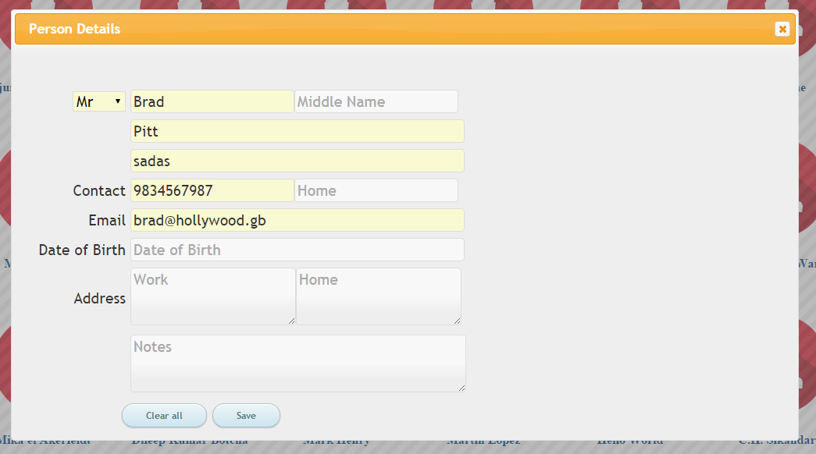
Figure 3 View person details

